Student stipend - creating value from grape marc

A problem identified within the New Zealand wine industry is the large and accumulating mass of wine waste, which is difficult to manage.
This is a big concern, as wine waste is an environmental burden and has financial impacts on wine businesses. Grape marc, which is the unused skin, seeds and stems left over after grape pressing, is a large component of this waste.
Currently, the only viable methods to reuse grape marc includes using it as compost or as feed for livestock. However, grape marc mass produced far exceeds that required for these uses. There is an urgent need to find other uses of grape marc, and particularly to come up with solutions that have commercial potential. Creating commercial value increases the incentive to use grape marc.
It is well-known that grapes have many bioactive phenolic compounds. One good example of this is a class of compounds called flavonoids. Some examples of very bioactive flavonoids found in grapes include quercetin, catechin and epicatechin. The bioactivity of these compounds includes antioxidant, anticancer, anti-inflammatory, antibacterial and cardiovascular protective activities. This implies that these compounds may have great potential to treat or help prevent development of human diseases.
The purpose of this study is to find ways to use grape marc as a source of these bioactive compounds that can be modified into products for the purpose of improving human health.

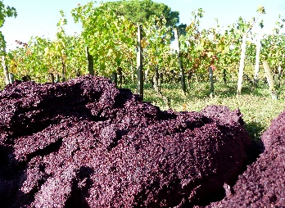
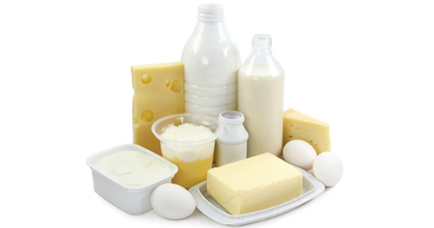
Product with derivatised flavonoids used for promoting health
Derivatisation
Grape marc extract with high amount of flavonoids
Larger Scale Extraction
Best identified derivatising agent
Sourced from
food products

