Supporting rapid diagnostic capability UC Davis, University of Bordeaux

Dion Mundy from Plant & Food Research attended the 11th International Workshop for Grapevine Trunk Diseases (IWGTD) in Penticton, Canada, in July 2019.
Grapevine trunk diseases diminish vineyard longevity and productivity in nearly every wine grape production region, causing significant economic losses to the wine industry worldwide.
Attendees included researchers and members of industry, with speakers from more than 20 countries covering a range of trunk disease-related issues.
Researchers had opportunities to visit a range of vineyards, where growers were open about the realities of managing vines with trunk disease without using registered pruning paste protections, and when the number of diseased vines had become economically damaging.
This year’s conference covered more physiology and chemistry topics than previous meetings, and large programmes of work from multidisciplinary teams were presented.
Metabarcoding and other methods of molecular detection were also presented with a move towards ecological studies of vines and vineyards rather than simple detection of a target pathogen. Advances in methodology also led to informal discussions between researchers around agreed common methodology and validation of detection methods to aid the comparison of results from different studies.
Research from Europe, particularly France, focused more on the esca complex and included trunk disease and wine quality interactions. This disease results from a combination of fungi that varies from region to region. Esca-associated fungi have been identified in New Zealand but, as yet, the distinctive leaf symptoms have not been reported.
Dion visited Californian vineyards with esca to see and photograph symptoms of esca on Sauvignon Blanc vines. Meeting international researchers enabled him to discuss the ecological function of esca-associated fungi found in New Zealand vines and confirmed the importance of investigating their roles further.
Plant & Food Research would like to acknowledge the funding received from the Marlborough Research Centre Trust to assist with this exchange. For a copy of the book of abstracts or any other related information please contact Dion Mundy directly at Dion.Mundy@plantandfood.co.nz
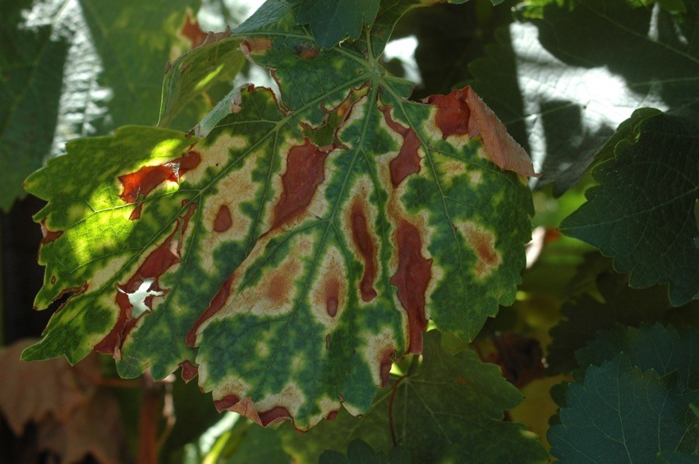
Esca Disease Complex in California

